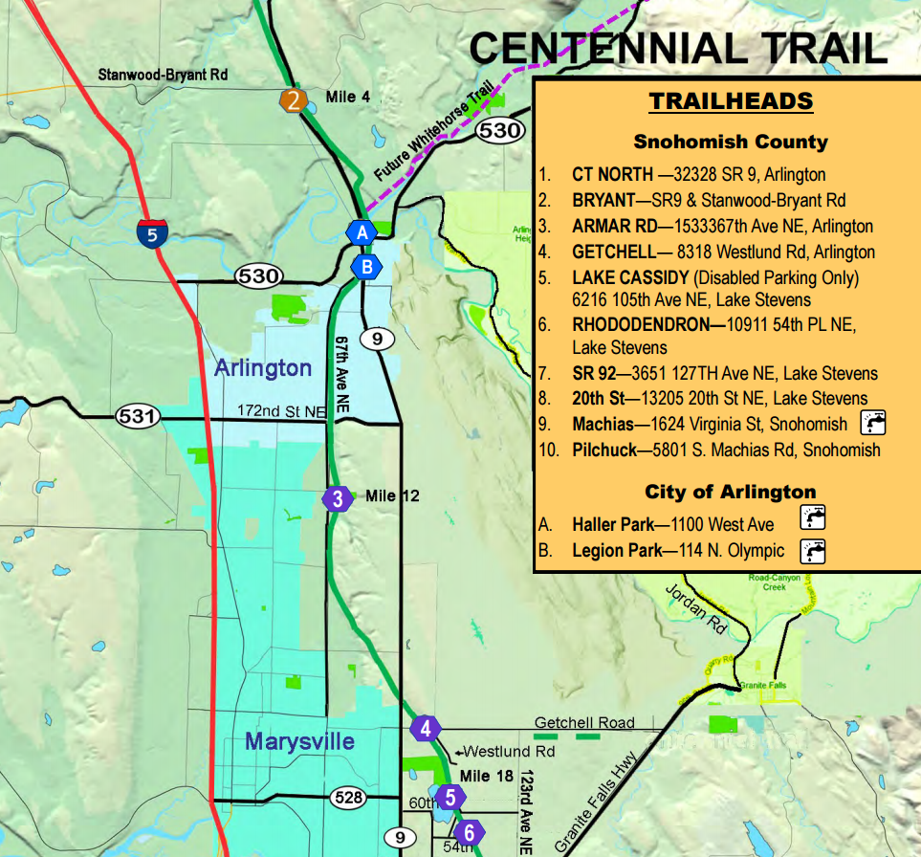

Centennial Trail Closure -

Hilltop Road (48.113837, -122.139759) to Wade Road (48.127549, -122.127788) due to a sinkhole and for summer construction.